**DAILY ONLINE ACTIVITIES SUMMARY**

|  |  |  |  |  |  |  |  |  |
| --- | --- | --- | --- | --- | --- | --- | --- | --- |
| **Date:** | **04-06-2020** | | | | | **Name:** | **Dhanush Shetty** | |
| **Sem & Sec** | **8 A** | | | | | **USN:** | **4AL16CS032** | |
| **Online Test Summary** | | | | | | | | |
| **Subject** | | **SMS** | | | | | | |
| **Max. Marks** | | **60** | | **Score** | | | **60** | |
| **Certification Course Summary** | | | | | | | | |
| **Course** | **AWS IoT: Vision Walkthrough.** | | | | | | | |
| **Certificate Provider** | | | **AWS** | | **Duration** | | | **10 mins** |
| **Coding Challenges** | | | | | | | | |
| **Problem Statement:**   1. **Python program to find sum of n numbers.** | | | | | | | | |
| **Status: Solved** | | | | | | | | |
| **Uploaded the report in Github** | | | | | **Yes** | | | |
| **If yes Repository name** | | | | | **Dhanushshett/online_c_coding_repository** | | | |
| **Uploaded the report in slack** | | | | | **Yes** | | | |

Online Test Details: (Attach the snapshot and briefly write the report for the same)

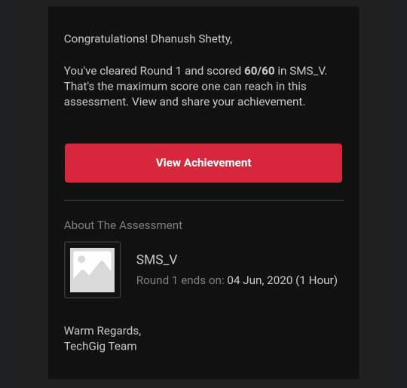

Certification Course Details: (Attach the snapshot and briefly write the report for the same)

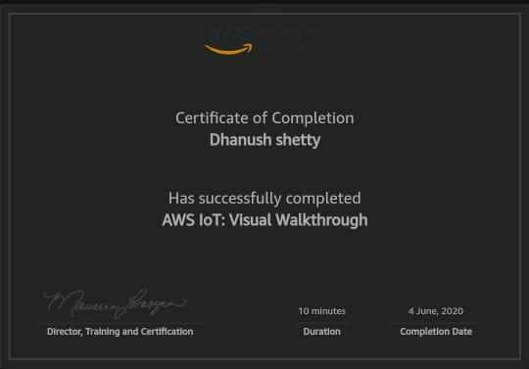

Coding Challenges Details: (Attach the snapshot and briefly write the report for the same)

**PROGRAM 1 .**

**// Python program to find sum of n numbers.**

**n=int(input(“Enter the number”))**

**sum=0**

**for i in range(1, n+1):**

**sum=sum+i**

**print(“Result:”,sum)**